THESIS
Student’s Name
Institution Affiliation
Date of submission.

Sensory impairment amongst the old

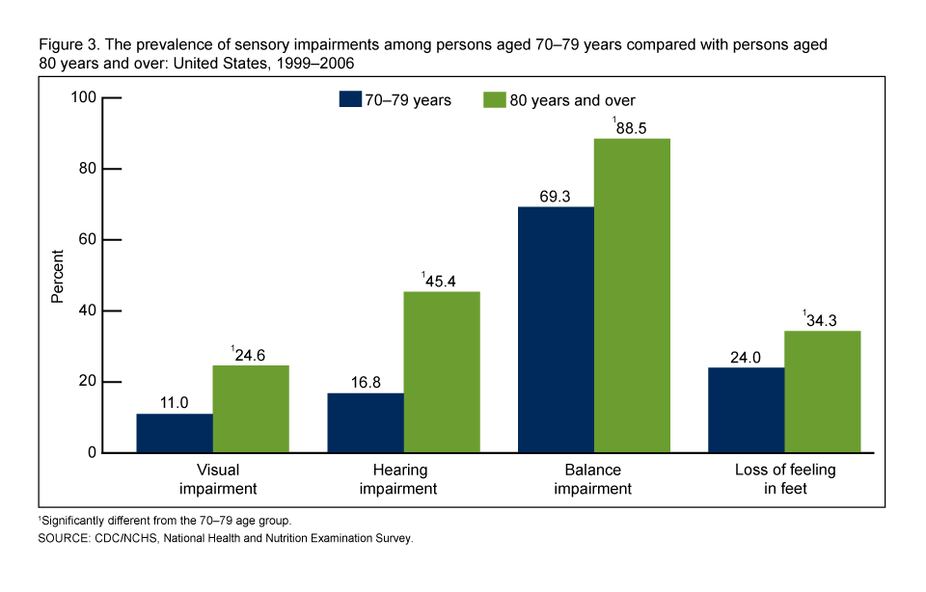
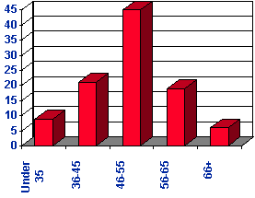
Was there question of interest? Did they follow instructions, if not? No need to say so now, but make a note & maybe let them know at a later time or privately. Have too many people already posted to this DB? If so...move on your comment should add value Clarity: Was it easy for you as a reader to understand what point they were making? Did they use descriptive statistics? How do you know? Relevancy: Did they use appropriate statistical tables to present your data? Kindness - on this DB best to be as kind as possible, no need to point out any mistakes...but if there is something that is not clear please do let person know your opinion
The thesis is about sensory impairment among the old. This will include visual, hearing, balance and loss of feeling in the limbs. The thesis will also include a comparison with other age gaps and the difference in loss of senses in the different ages compared to the senior citizens.
On the graphs above there were questions of interest. The first one is a descriptive graph regarding the physically impaired in the old. The graph compares and contrasts those who have visual, hearing, balance and loss of feeling in the feet. the second graph compares the general population in regards to the same impairment, that is visual, hearing, balance and loss of feeling in the feet. the instructions were followed since from the definition of descriptive statistics which is description of data in summary, both graphs have captured the data and described it in the graphs. Not so many people had posted t this db. and thus my comment can add value as they don’t have so much to read from.as a reader it was easy f me to understand as the graphs were explanatory and they were well labeled and the topic was well researched and hence it was easy for me to understand what was going on. Descriptive statistic was used as they were able to summarize the findings and put it on the graphs without using so many different words and charts.
Statistical table shows value distribution functions, probability function, probability density so as to ascertain whether the statistical result exceeds the level of the required significance. The graph portrays the statistical table as it shows the distribution function, probability density and its able to capture values to show that the results matches the required.

Bibliography
https://www.statisticshowto.com/probability-and-statistics/descriptive-statistics/
Trochim, W. M., & Donnelly, J. P. (2001). Research methods knowledge base (Vol. 2). Atomic Dog Pub..

